Remaining work

Document content:

Casemanager inputs 2
Planned features 6
Login Page 6
Dashboard Page / Sidebar 7
Case Page 9
Chat Page 10
Chat and Case Page 12
ChatOverviewPage, Casepage, CaseOverviewPage 14
All Views 15
Other 17
Discovered bugs 17
Places that could use refactorering 19

Note:
In order to not make this handoff document a thousand pages long, the handoff has been split into two separate documents.
- Document 1: Remaining Work (this document) covers everything directly actionable for the next group: feedback from casemanager user tests, planned features not yet implemented, discovered bugs, and places in the codebase that would benefit from refactoring.
- Document 2: Frontend Alternatives covers two bigger perspective architectural questions that go beyond individual features.Handoff frontend: part two
Both documents are intended as a starting point, not a complete specification. The recommendations include references to official documentation and concrete implementation pointers, but intentionally avoid over-specifying solutions that the next developer should evaluate in context.

Casemanager inputs

Usertest 1
#234 Heidi Note usertest - Heidi

(Green for Done, Yellow for Implemented and Red is for not planned)
User Feedback Feature | Description | Status | When (During / After Bachelor)
ChatOverviewPage +  CaseOverviewPage +  Sidebar:  Deletion Confirmation | Adding an "Are you sure?" pop-up window due to user concerns about easy deletion. | Done  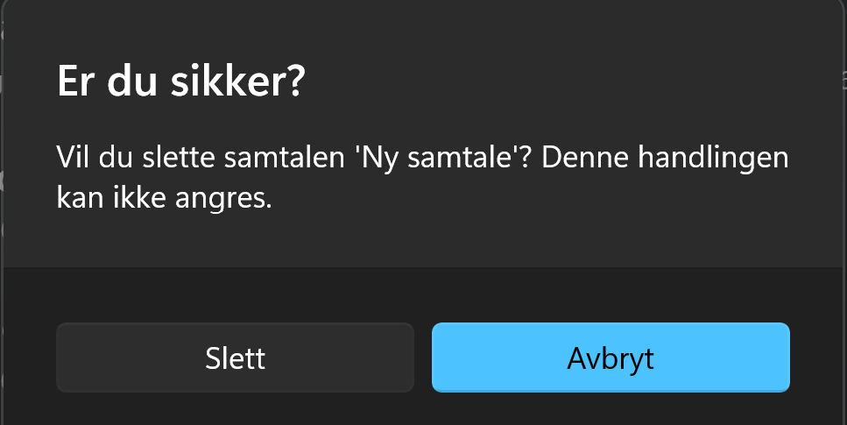 | During Bachelor
"Alle Samtaler” page:  shows if a Chat connected to Case | Displaying whether a conversation is linked to a case or not within the conversation description. | Done   | During Bachelor
"Alle Samtaler” page:  Active Filter States | Making the filter button reflect if the | Done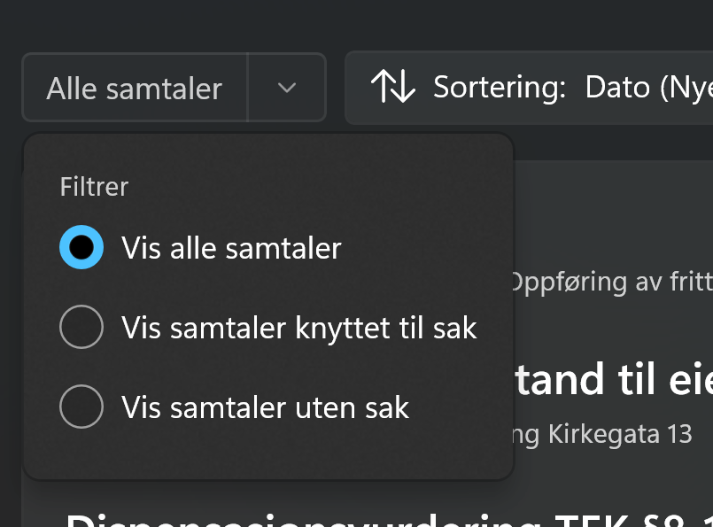 | During Bachelor
ChatPage:  Document Viewer In-Browser  (accessing webpages)   | How sources are opened:  Ensures that when a user clicks a source reference inside a chat, the document/webpage opens directly within the web browser for seamless reading. | Planned | After Bachelor  (Intended feature)
ChatPage:  Uploaded Documents Overview  (showing documents)   | Providing a visual source view in LLM responses to easily see which documents have been added | Planned | After Bachelor (Intended feature)
360 System Integration (Backend heavy tasks) | Automatic integration with the 360 system and linking against cases | Planned | After Bachelor

Usertest 2 and 3
#246 Bjørg and Mari

User Feedback Feature | Description | Status | When (During / After Bachelor)
Terminology Adjustments | Changing terminology from "Archive/Reopen" to "Close/Open cases" Updated "Dine saker" to "Alle saker",  Renaming "Case" to "[Our App Name] Case" to avoid confusion with Plan & Build 360 | Partly done, only ones missing is "Case" to "[Our App Name] Case" due to:  - Lack of the applications name  - Don't know if it is necessary | During Bachelor  (if necessary after)
ChatPage:  Title Management on Conversation Page | 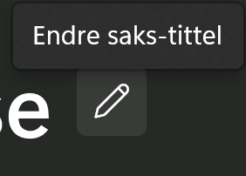  Allowing users to manually change/edit the conversation title on the conversation page while waiting for auto-generation | Done   | During Bachelor
[Repeaded]  ChatPage:  Document Viewer In-Browser  (accessing webpages)   | How sources are opened:  Ensures that when a user clicks a source reference inside a chat, the document/webpage opens directly within the web browser for seamless reading. | Planned | After Bachelor  (Intended feature)
[Repeaded]  ChatPage:  Uploaded Documents Overview  (showing documents)   | Providing a visual source view in LLM responses to easily see which documents have been added | Planned | After Bachelor (Intended feature)
ChatPage:  External API & Database Connections   | Showing exactly which external APIs and sources the specific case has access to within the Source Component. | Not Planned, but can be implemented if necessary | Maybe After Bachelor
ChatPage:  Automatic Conversation Title Generation | Automatically generating titles for conversations based on the context of the chat. | Planned (Intended feature) | After Bachelor
Sidebar:  Context Menu for cases and chats | Adding a context menu in the sidebar for quick management of cases and conversations. | Done  Rightclick displays different options for Cases:  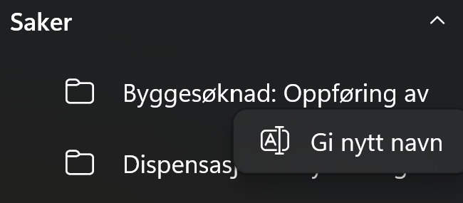  Chats:  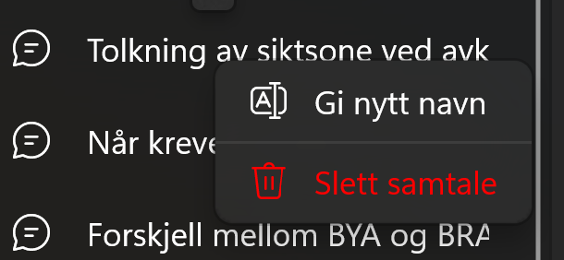 | During Bachelor
Sidebar:  UI differentiation between creating a new chat or case | Updating the sidebar UI to clearly differentiate between creating a new conversation/case | Done  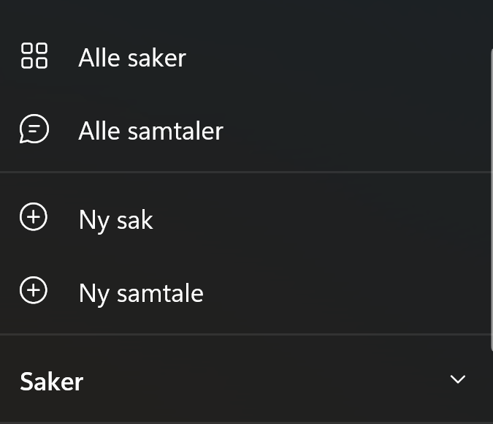 | During Bachelor
Sidebar:  Optimized "New Conversation" Creation | Preventing spam in the sidebar by ensuring a "New Chat" object is only created after the user sends their first message | Done | During Bachelor
All relevant pages:  Contextual Onboarding Instructions | Implementing step-by-step onboarding instructions for first-time users to navigate | Planned (Intended feature) | After Bachelor
CreateCasePage:  Address Reminder to include the case address | Prompting users to include the case address in the title via placeholder text, onboarding instructions, or a hover tooltip. | Done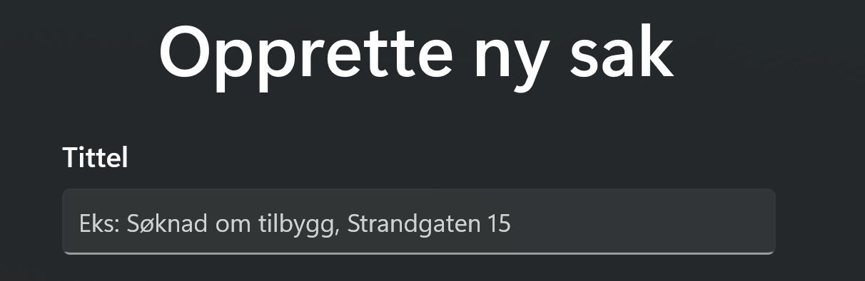  (not tooltip as this is redundant) | Under Bachelor
ChatPage + ChatOverviewPage +  CasePage:  Change Caseconnection for a Chat | Change Caseconnection for a Chat, by either…  - Move a Chat from one Case to another  - After starting a new chat without a case connection, assign it to a Case | Planned (Intended feature) | After Bachelor
Sidebar:  Conversation History Search | Adding a search bar/functionality to look up specific content from past conversations (e.g., previous dispensations). | Planned (Intended feature) | After Bachelor

Remaining Work
Disclaimer: Because of lack of time, some of the potential implementations is suggestions from AI, so it may not be applicable

Planned features

Login Page

Add the validation function to the text boxes in the login. Textbox extensions
Where: LoginPage
Current version: Only Textbox for email and Password box with basic validation methods in LoginViewModel

Potential implementation:
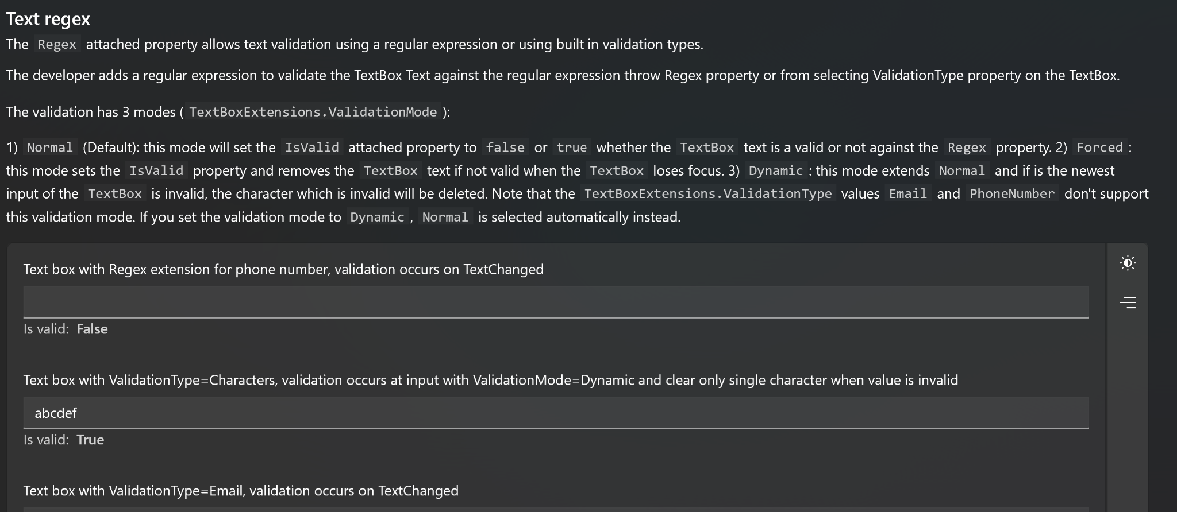
Sources
Github repo
Nuget Packet for Toolkit Textbox Validation Extensions

Dashboard Page / Sidebar

Rename / Delete case / chat reflects in Sidebar Dashboard/Sidebar:

Connect backend to rename (content dialog) in Sidebar
Where: DashboardPage code-behind / DashboardViewModel, Sidebar component
Current version: Rename via ContentDialog is implemented in the UI but the confirmation does not reflect the change back to the backend/data layer.Backend call is missing int the confirm handler.
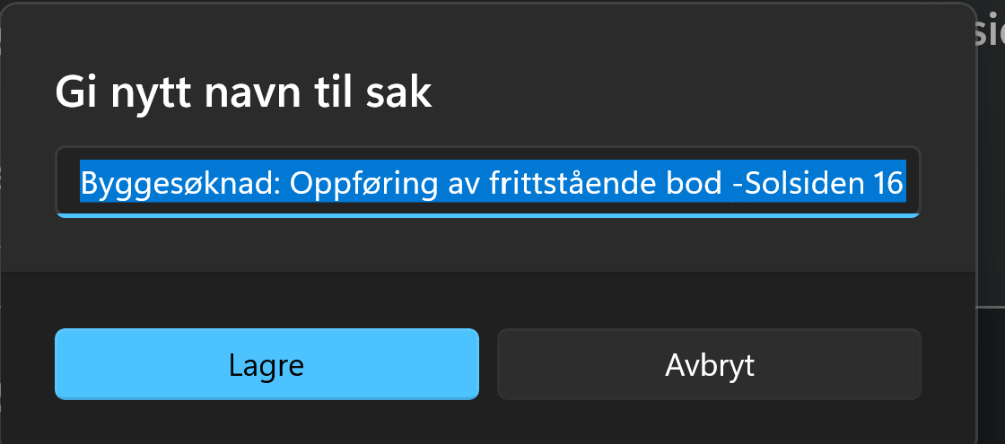

Rename / delete case / chat in the different views in the application - that automatic refreshes list in Sidebar
Where: CasePage, ChatPage, ChatOverviewPage, CaseOverviewPage + Sidebar NavigationView items
Current version: Rename or delete on a page does not propagate back to the sidebar item list in DashboardViewModel.
Potential implementation:
- Use the Messenger pattern (already in use in project): broadcast CaseRenamedMessage / ChatRenamedMessage / CaseDeletedMessage from the originating ViewModel
- DashboardViewModel subscribes and updates the relevant ObservableCollection
Alternatively: if using a shared service layer, ensure collections are derived from the same source-of-truth list

Enable search field (with the possibility to search through case- and chats-content
Where: DashboardPage Sidebar
Current version: No search functionality. Users must scroll through all cases/chats manually. 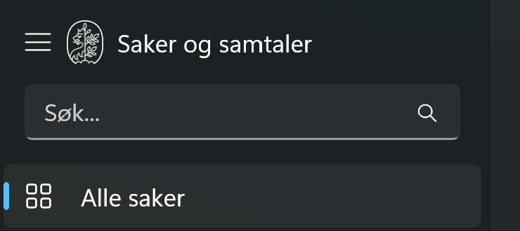
Potential implementation:
- Bind AutoSuggestBox and filter binding at the top of the sidebar list and overview pages
- Bind input to a filter predicate on the AdvancedCollectionView (already used for sorting/filtering on ChatOverviewPage): extend with Filter = item => item.Title.Contains(query, OrdinalIgnoreCase)
- For content search (inside messages): requires backend endpoint; out of scope for pure frontend implementation
Sources:
AdvancedCollectionView (CommunityToolkit)

Case Page

Add sorting functionality to Chats viewed in CasePage, e.g by date
Where: CasePage
Current version: Add Sorting component that sorts by date (used in ChatOverviewPage) to Chats in CasePage, e.g where the red square are placed. 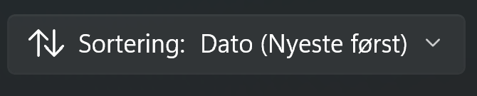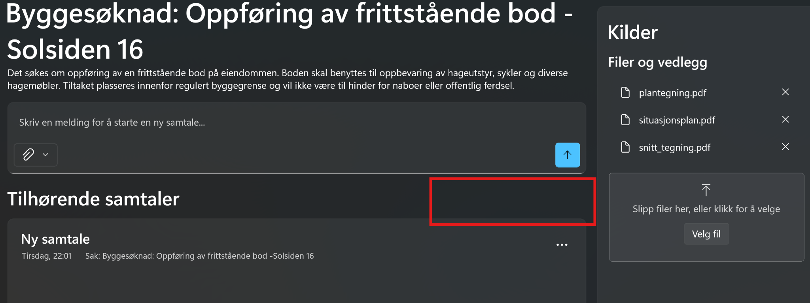

CasePage: possibility to rename case (for chat)
Where: CasePage
Current version: Rename is implemented for ChatPage via an inline editable title.
CasePage has no equivalent.
ChatPage  (already implemented) | 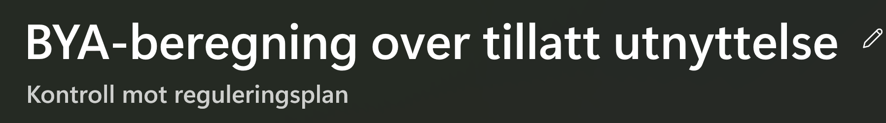
CasePage | 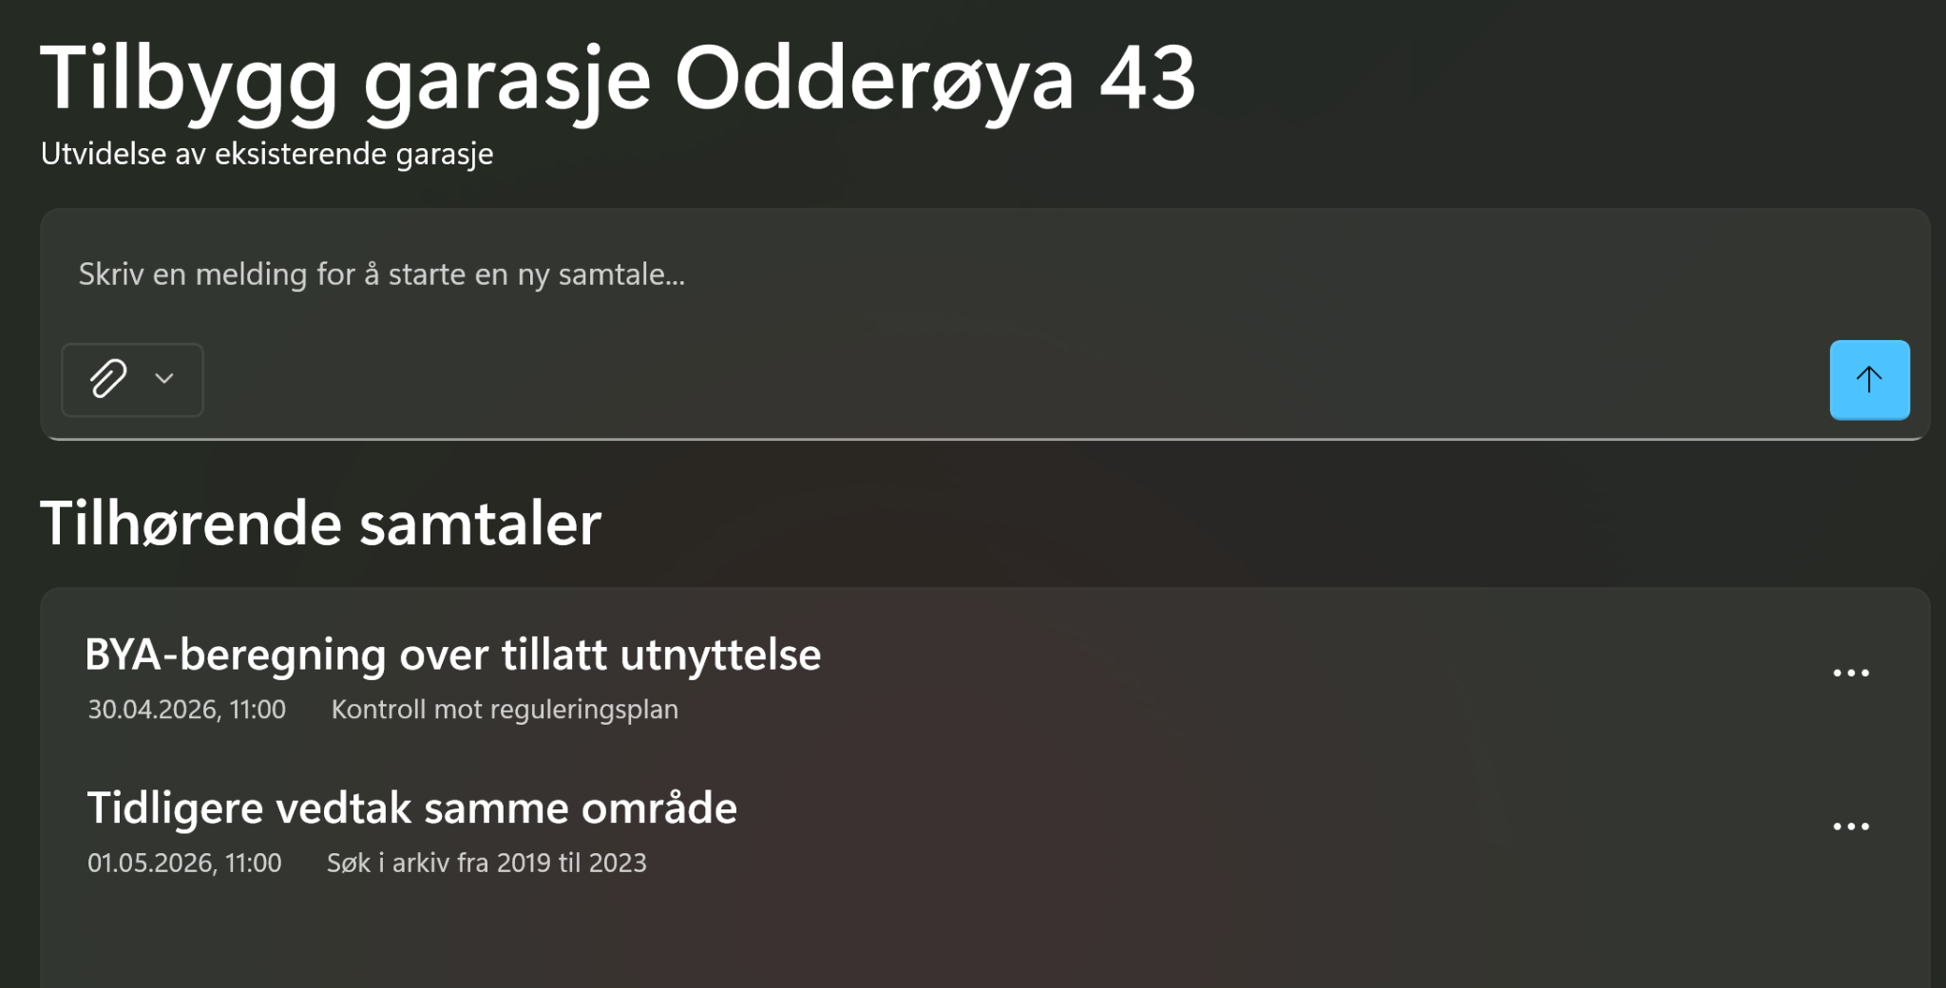
Potential implementation:
- Reuse same pattern as ChatPage: editable TextBox toggle on title click, bound to a RenameCommand in CasePageViewModel
- Trigger via pencil-icon button next to the case title (same icon as in ChatPage)


Chat Page

Options for composing the Chat
Where: ChatPage
Potential implementation:
To address the unavoidable response lag that occurs when managing long conversations and extensive contexts, the following two solutions are proposed
UI
- Complex: Add a button to summarize the conversation and then directly be navigated to another chat with the former chats context summarization
- Easier: Add a button to summarize the conversation into a new conversation (then a user has to copy into a new chat)
- Easiest: A form for a reminder to the user, to summarize the conversation and encouragement to copy this into a new chat
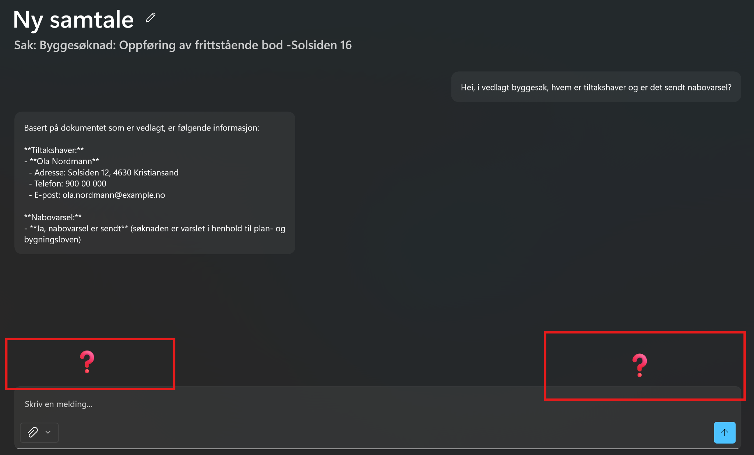
Backend assignment
- Complex: Shorten the context of the conversation in those cases where the conversations are very long (backend assignment)
- RichTextBlock (WinUI 3)

LLM response: Enable selecting text and reply with marked text
Where: ChatPage, message bubble component
Current version: LLM responses are displayed with having to manually select and copy text.
Potential implementation: Replace read-only TextBlock with RichTextBlock which is better for supporting native text selection and built-in copy via context menu
- Reply with marked text: handle SelectionChanged on RichTextBlock, store selected text in ViewModel, pre-populate ChatInputControl with > {selectedText} prefix

- Copy button: use DataPackage + Clipboard.SetContent() where a DataPackage holds the payload, and Clipboard.SetContent() commits it to the Windows clipboard.

Sources
- RichTextBlock (WinUI 3)

Chat and Case Page

ChatInputControl: Open attachment in default app (AttachmentOpenRequested)

Where: ChatInputControl (used in ChatPage and CasePage)

Current version
Attachment pills are displayed in ChatInputControl, but clicking an attached file does nothing.

Potential implementation
- Handle the AttachmentOpenRequested event in ChatInputControl.xaml.cs
- Use Windows.System.Launcher.LaunchFileAsync(file) to open the file in its default app
- Retrieve the StorageFile from the attachment model using its path before launching

Sources
Launcher.LaunchFileAsync Method

Enable removing all attached files at once (via ClearAllRequested)
Where: ChatInputControl (both xaml and xaml.cs)
= Reusable control for user chat input box, used in: ChatPage and CasePage

Current version:

Visualise chat and case connection
  - CasePage: When a user wants to move a chat connection from one case to another
  - ChatPage: After creating a new conversation without a case, make sure that the user can assign a chat to a case
Where: ChatPage, ChatOverviewPage and CasePage (possibly sidebar in dashboard?)
Current version:
CasePage:
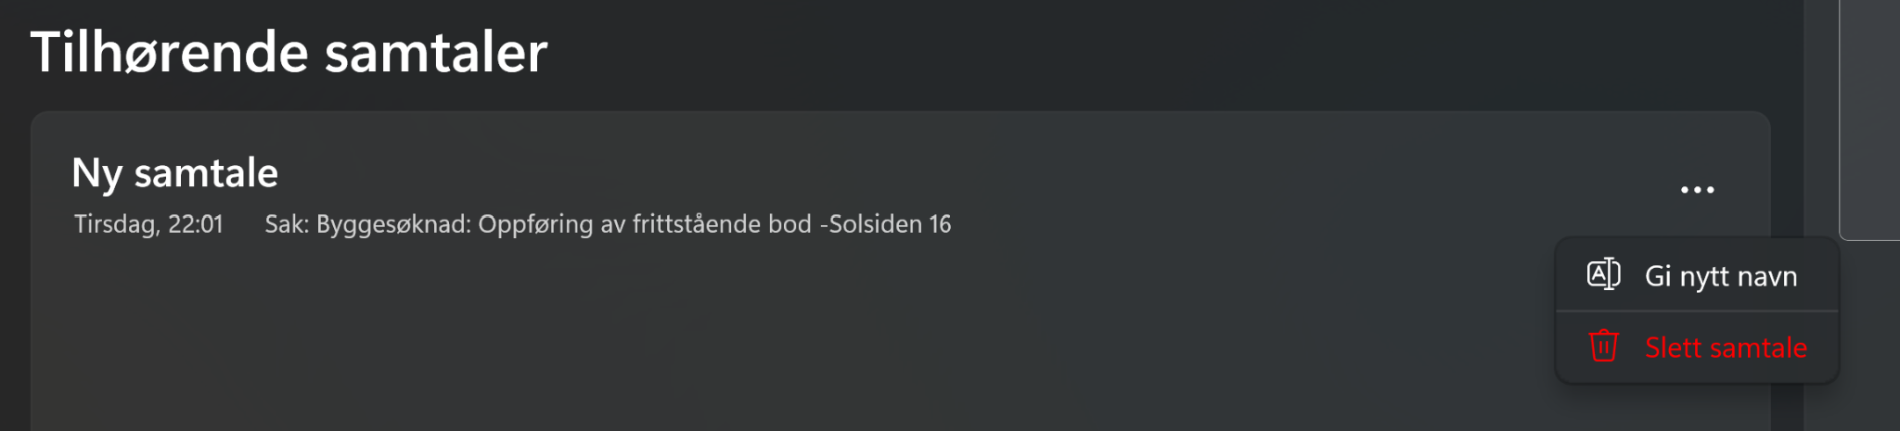
ChatPage:
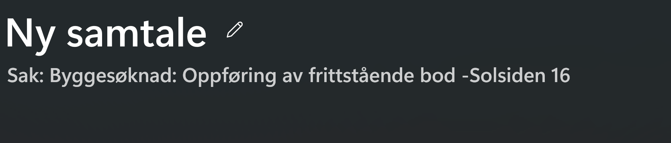
Potential implementation:
- CasePage: Add a new option in the chatsinputcontrol’s Menu Flyout that show a pop up where the user can choose another case connection
- ChatPage: Replace the edit icon with tree dots and add a Menu Flyout that show a pop up where the user can add a case connection

ChatOverviewPage, Casepage, CaseOverviewPage

Delete all chats / cases functionality with select all → delete
Where: ChatOverviewPage, Casepage, CaseOverviewPage:
Current version: Manually deleting each case or chat:
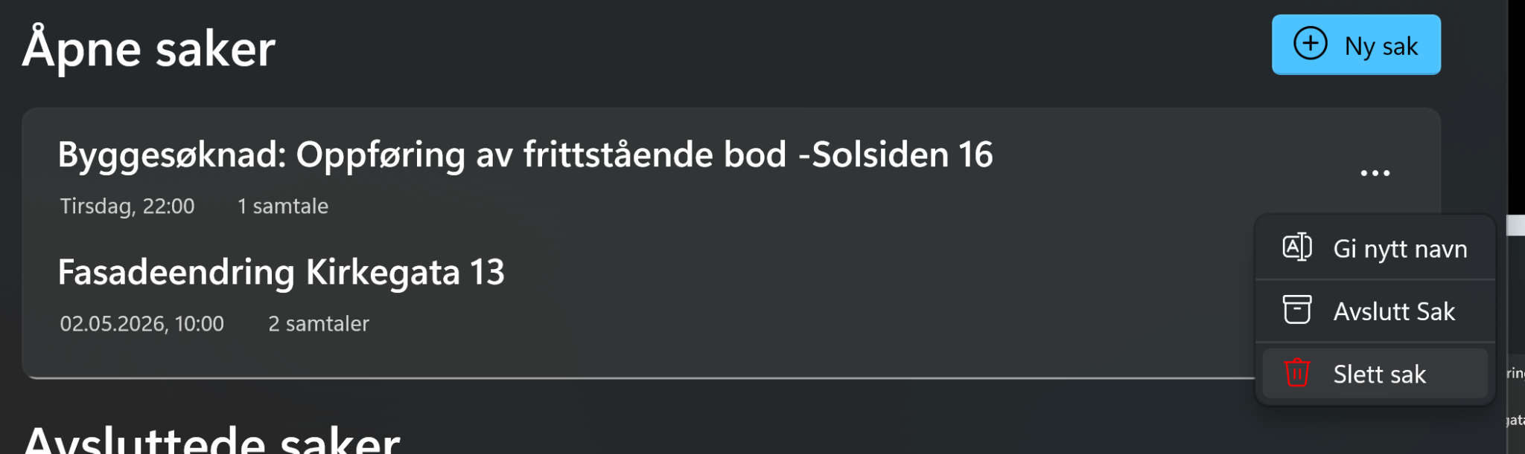
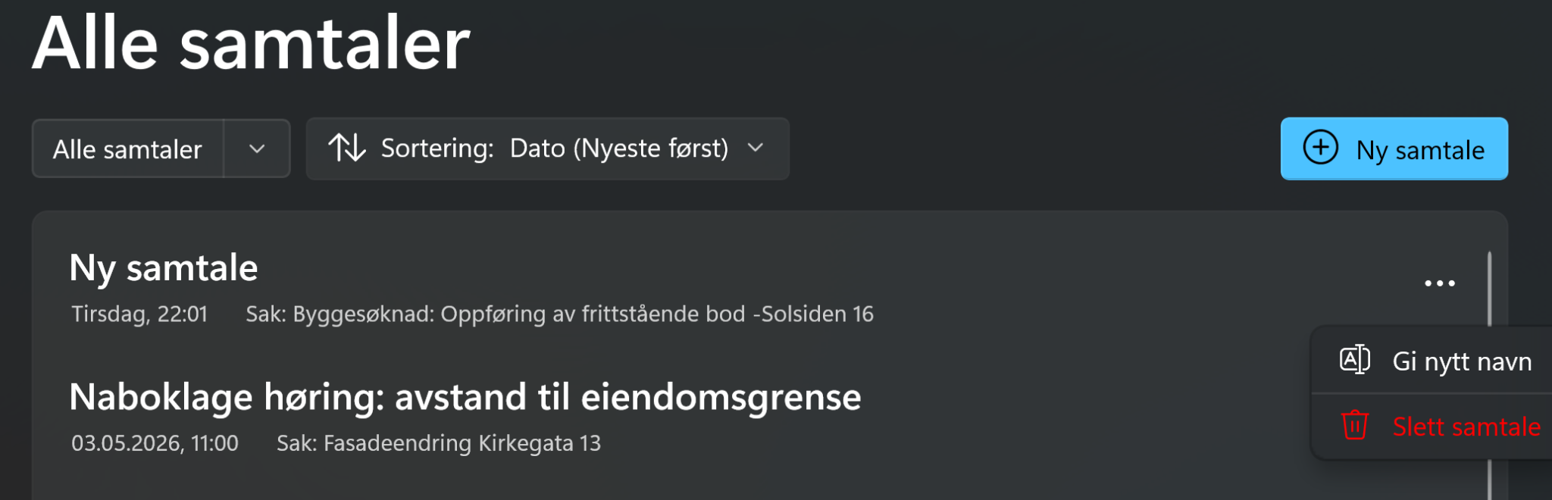

Potential implementation:
- Via setting CaseListView /ChatListView to Selection mode to multiple to enable multi-file selection
- Then set the IsItemClickEnabled property so that users click an item (for example, a button) to invoke an action instead of selecting the item.
- If you set the IsItemClickEnabled property to true, you must set the SelectionMode property to ListViewSelectionMode.None. Handle the ItemClick event to respond to the user interaction.
Sources: List and Grid View ListView Control

All Views

Facilitate Responsive layout
Enable responsive and dynamic layout for different components in the application,
Layout uses hardcoded widths/heights (e.g. MaxHeight on KilderBorder and FileListControl). No VisualState-based adaptation for small vs. large windows.especially for different sizes for components for different window sizes (small, medium, large).
Where: All Views in the Application
Potential implementation:
- Use AdaptiveTrigger with VisualStateManager blocks in XAML for MinWindowWidth/MinWindowHeight breakpoints (small, medium, large)
- Replace hardcoded MaxHeight with VisualState-driven Setters
- Apply RelativePanel or Grid with star-sizing for fluid column/row resizing
- For list controls (CaseListControl, ChatListControl): add early visual differentiation via VisualStates (e.g. compact vs. comfortable density)
Sources:
- VisualStateManager (WinUI 3)
- Adaptive layouts with XAML

Onboarding instruction to user when first trying the application
Where: All primary pages (DashboardPage, CasePage, ChatPage, CreateCasePage)
Potential implementation:
- Use TeachingTip controls (WinUI 3 built-in) attached to key UI elements:
"New Chat" button, "New Case" button, source panel. Store an IsFirstLaunch flag in settings.json (already used in the app); show tips only once
- Chain tips sequentially with ActionButtonClick to go to next tip
Sources:
TeachingTip (WinUI 3)

Enable the possibility to copy text in different views
Where: All view pages, especially CasePage with the case
Current version: Only possibility of copying text is in ChatsPage.
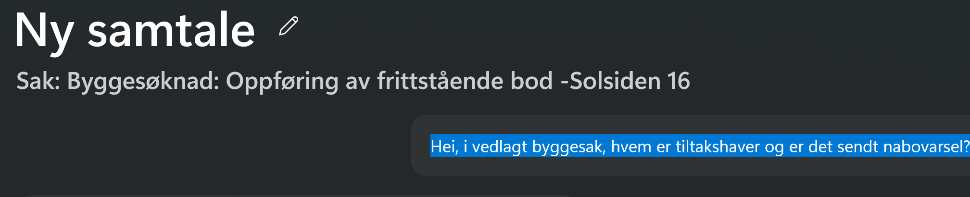
Potential implementation: Replace read-only TextBlock with RichTextBlock?
RichTextBlock (WinUI 3)

Add and visualize various error messages or loading visualisation
Where: All pages with async operations (espacially ChatPage, CasePage, CreateCasePage)
Current version: The only error message in the application is in the loginpage
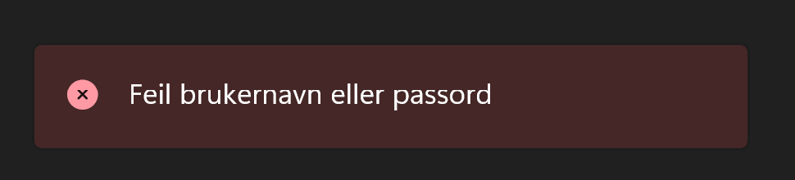
However, the remaining errors from backend/API calls are only logged, lacking in user-facing error feedback.
Potential implementation:
- Add InfoBar controls (WinUI 3) bound to an ErrorMessage property in each ViewModel: severity Error/Warning/Informational as appropriate
- Possibly: Centralize via a shared INotificationService injected into ViewModels:
call ShowError(message) which sets a bindable state in a shared overlay or page-level InfoBar
- Specific cases to handle: LLM timeout, file upload failure, login error, case/chat save failure
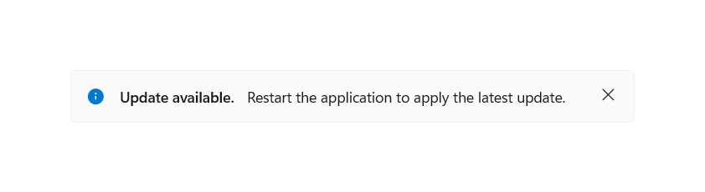
Sources:
InfoBar (WinUI 3)

Other

Standarize themes
Where: generic.xaml, App.xaml, all control styles
Current version: The app uses some theming but hardcoded colors and sizes exist across pages. generic.xaml is not fully leveraged for consistent control styling.
Potential implementation:
- Audit all hardcoded Color, Brush, FontSize, CornerRadius values across XAML files and replace with ThemeResource / StaticResource references defined in generic.xaml
- Define semantic tokens: AppBackground, CardBorder, PrimaryAccent etc. rather than raw hex values
- Enables light/dark theme switching (tied to the existing theme bug in settings.json) to work correctly across all controls automatically

Discovered bugs
- The settings stored in '.../AppData/local/LocalLLMApp/settings.json' does not get loaded when opening the application. So the "settings we want" are not used when we launch the application. Changes are only done when you are on the settings page and change the "Theme" there
- In Chatpage, timestamp wont show up on ChatPage for each ChatMessage, even though it was implemented in issue #215 and it showed up a few commits ago
Before:
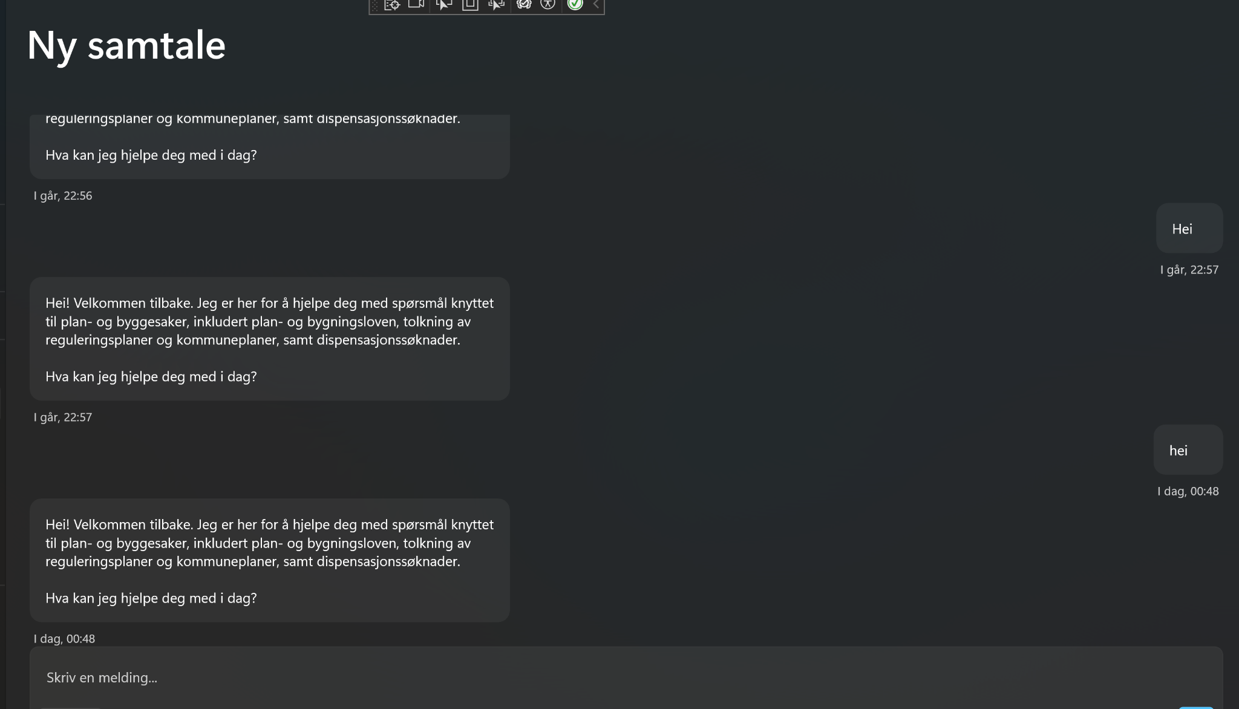
Now:

- Create New Case' button moves on hover (introduced after Jon refactored the component logic from CreateCase-code-behind to ViewModel)


- A white square appears in left upper corner in the sidebar (dashboard) - after login [writing email and password] and pressed enter in the login (in other words, not clicking on anything in the application)
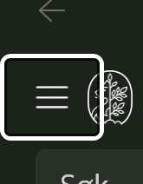
- DashboardViewModel.HandleCaseRename og HandleChatRename:
The newName parameter is ignored. The title is never updated on the object before UpdateCase/UpdateChat is called.

Places that could use refactorering
- CaseModel: Move ChatCountDisplay, ArchiveMenuText and ArchiveMenuGlyph from CaseModel to UI in order to keep MVVM structure.
- Standardise components used often or spread logic
- Standardise CreateChat logic
- Contentdialog - rename / delete.
Potential implementation: Static DialogHelper-class (CaseOverviewPage, ChatOverviewPage, CasePage) → UserControl, and then set the UserControl as the Child of the Popup
- Filtering and sorting (via AdvancedCollectionView)
- for ChatOverviewPage – > Filtering og Sorting
- CaseOverviewPageViewModel → Archive/Active filtering
- DashboardViewModel - Recent items tracking

